City of Seattle
3.1 MMTCO2e per year
Community Greenhouse Gas Emissions Inventory (seattle.gov), page 11
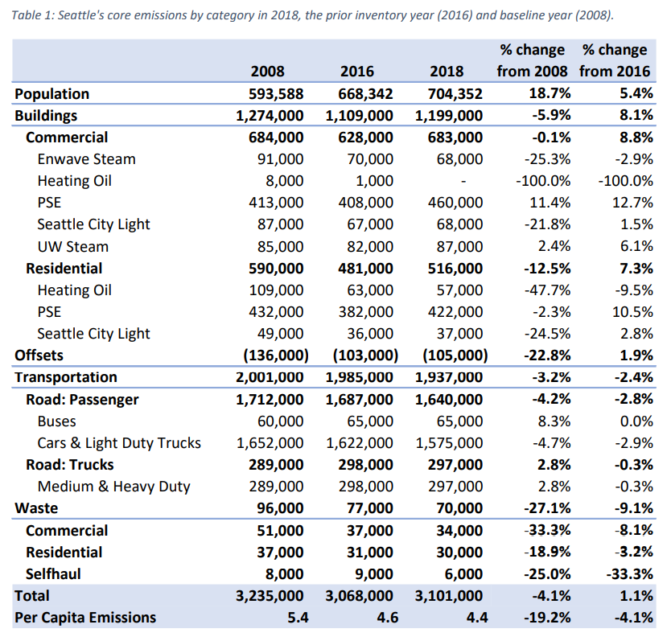

Bellevue
1.61 MMTCO2e per year
City of Bellevue Environmental Performance Dashboard (arcgis.com)

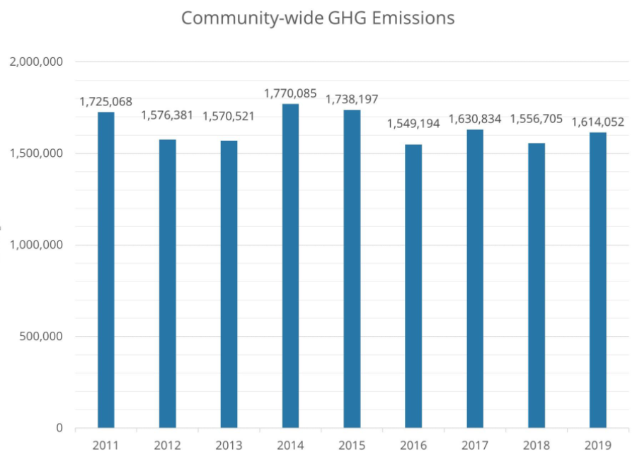

Tacoma
  - MMTCO2e per year

CityofTacoma-GreenhouseGasEmissionsUpdateReport2016.pdf, page 6

